**ASSISTED PRACTICE (HTML ASSERTION)**

Step1: Open Jmeter -> Add Thread Group to Test Plan

Step2: Right click on Thread Group -> Add -> Sampler -> HTTP request

Step3: In HTTP request -> Give protocol as “https” -> Server as “blazedemo.com” -> Path as “/”

Step4: Right click on HTTP request -> Add -> Assertions -> HTML Assertion

Step5: In HTML Assertion -> Browse the file name where we have to save the errors of website -> Go to our desktop folder where we saved the Test Plans -> Create another folder in that folder and give any name to this folder -> In this, save the file name as e.g.(errors.txt) -> Save it

Step6: Right click on Thread Group -> Add -> Listener -> View Results Tree

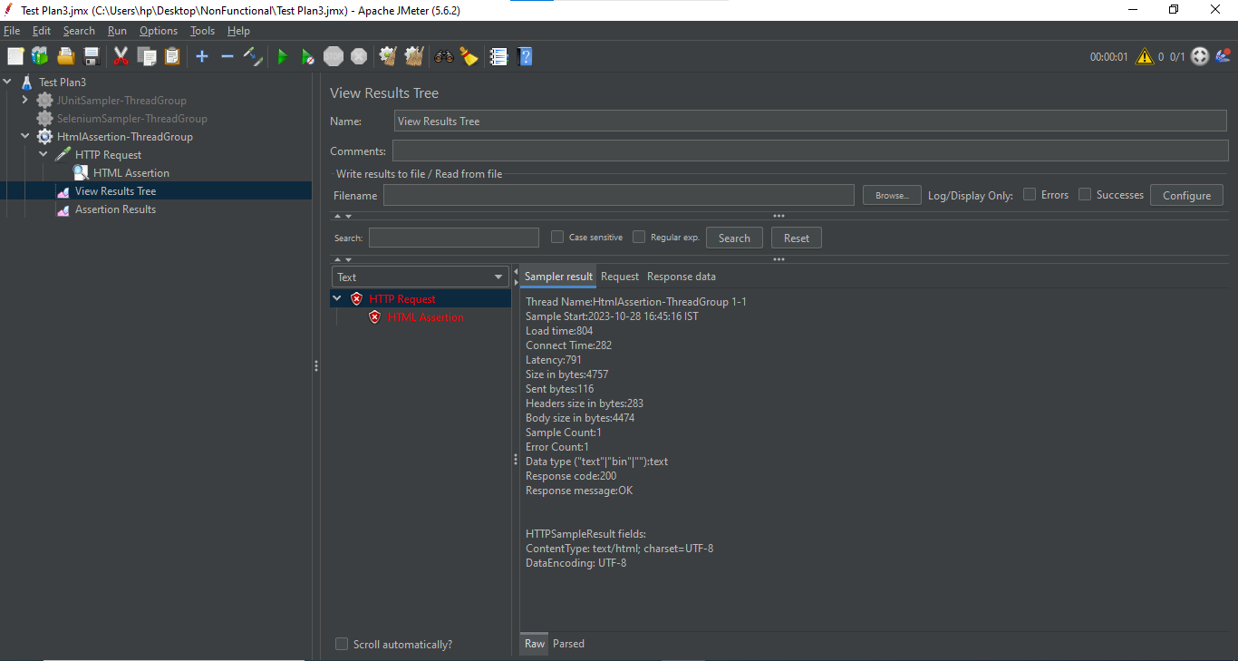

Errors File(Errors in Web Page):

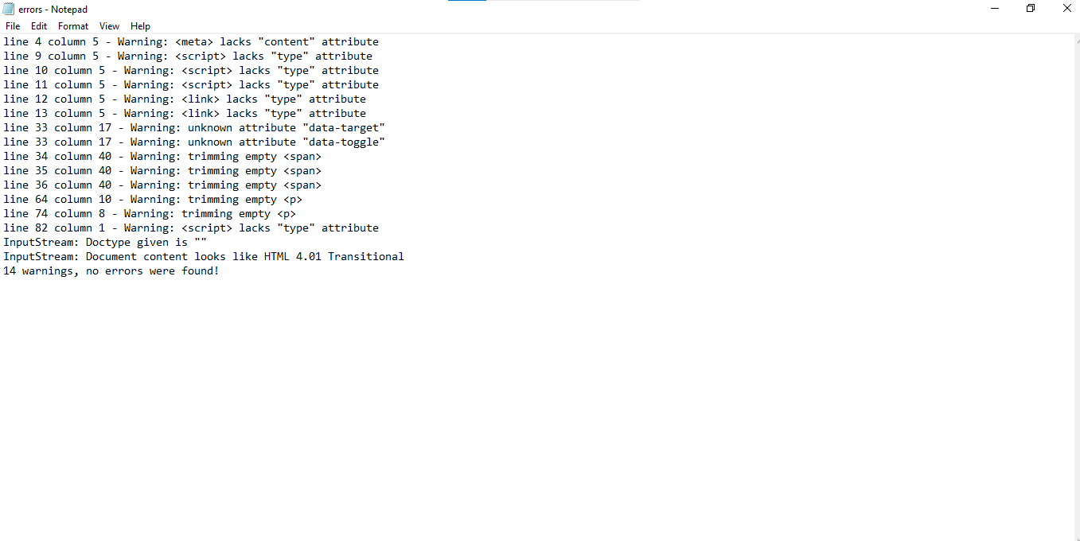

Step7: Right click on Thread Group -> Add -> Listener -> Assertion Result

